Hi Year 2!

I hope that everyone is well and is managing to work though some of your learning pack that we sent home!

I am going to be writing to you every week as you complete work, and give you some new ideas about what you can be doing to make sure that you keep up with your learning. My email address is: b.wilson@hightersheath.co.uk – please send me any questions that you have, or any photographs of the work that you have been completing – I’d love to see and it would be great to hear from you!

English
Reading - What books have you been reading? Perhaps you could draw a story map about the story you have read? Who are the main characters? Who do you think in our class would like this book and why?

Writing – What would you do if you found a tiny dragon?
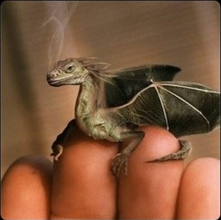
Can you write a short story about the adventures of you and the tiny dragon? Perhaps you dragon is magic! What are its powers? Is it a good dragon or an evil one?
Can you describe the dragon using different adjectives? You could use an online thesaurus to help you find even better describing words.

Maths
I want you all to practise your tables this week, remember to go onto TT Rockstars for at least 10 minutes every day!! Remember you need to know your 2s, 3s, 5s and 10s really well. Maybe you know the inverse-division for each times table?

Other
I would love to see any art work you have completed – remember that our topic is The Arts and Crafts Movement. William Morris is a great artist to start exploring! Perhaps you could create your own tile or your own wall paper design by putting lots of sheets of paper together and repeating the pattern.

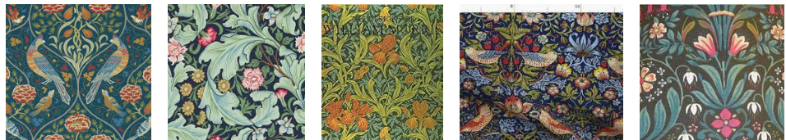

I will look forward to reading some of your emails!
Stay safe and remember to wash your hands!

Mrs Wilson

