Hi Year One!

I hope that everyone is well today and is managing to work through some of your learning pack that we sent home! There are lots of different things to do and we want you to enjoy it.

I am going to be writing to you every week and give you some new ideas about what you could be doing to make sure that you keep up with your learning. My email address is: j.kelly@hightersheath.co.uk – please send me any questions that you have, or any photographs of the work that you have been completing – I’d love to see!

English
Reading - What books have you been reading? Perhaps you could let me know. Remember that we were looking at books written by Julia Donaldson? Maybe you’ve read some more. You can find some of the titles of her books on her official website: http://www.juliadonaldson.co.uk/index.php

If you Like listening to stories, and having a go at listening activities, then look at https://www.bbc.co.uk/cbeebies/radio

Writing - I saw this picture and think it’s really interesting:
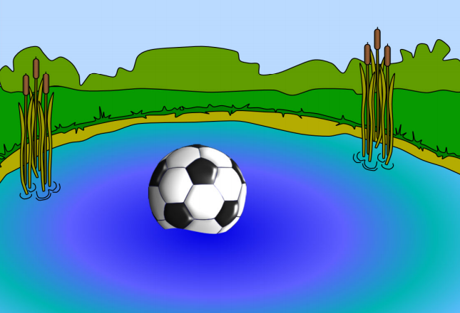
What is in the pond?
How did it get there?
Did the owner get it back?
Try and write some sentences but remember:
capital letters, full stops and finger spaces.

Read it back to check the sentences make sense and use your phonics and sound friends to try and spell new words.

Phonics – Have you been practising your sounds? Take a look at the “Phonics workshop” handout pack that you have all been given and check the groups of sounds you need to practise. Play some fun phonics games, use the weblinks and Mr. Thorne Youtube videos!

Maths
I want you all to practise counting in 2’s 5’s and 10’s this week. Challenge: Can you practise saying them backwards? Perhaps you could find items around the house and group them in 2’s, 5’s, and 10’s. Remember to ask first! Maybe you could take a picture to show me.
Carers: Something else to look at is the latest offer from the Maths Zone.
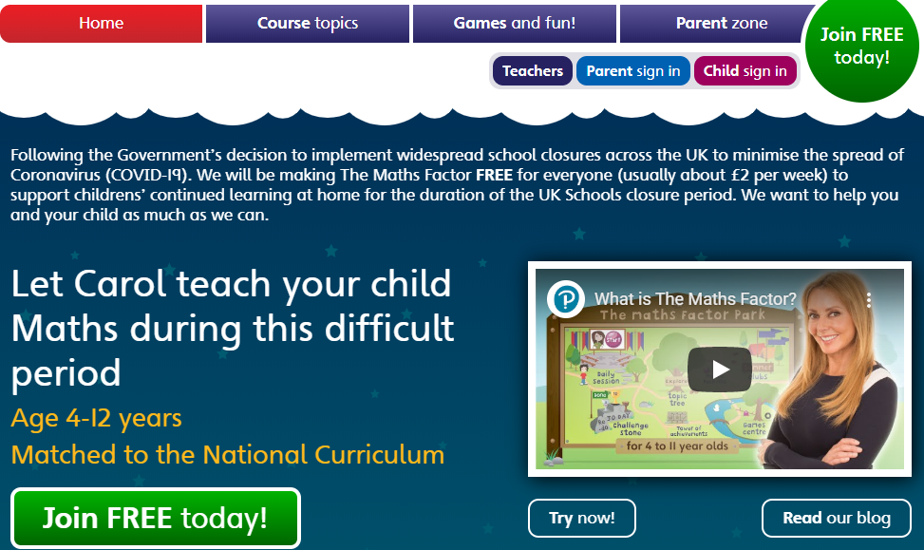
https://www.themathsfactor.com/

Other
I would love to see any art work you have completed – remember that our topic is Plants. As we are seeing beautiful signs of Spring, perhaps you could create some lovely art pieces showing this.
For DT we were about to make some cress sandwiches. Perhaps you’ve been helping a grown up to make sandwiches at home and could write down the steps. Start your sentences with First, Then, Next and Finally. Just remember to always have an adult to guide you and to tidy up when you have finished!

Don’t forget that when using the internet to follow the e-safety guidelines and share what you are doing with a grown up.

Well, that’s all for now. Keep well and remember to wash your hands! I’ll write another letter to you all next week.

Bye for now!
Mr Kelly

